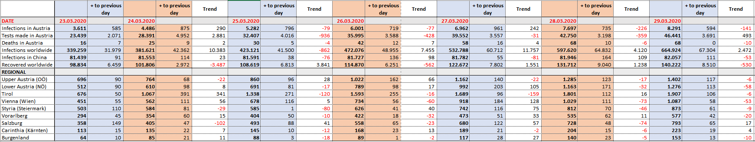

**Follow-up list of the development of Coronavirus in Austria, week 13**